**Exercise 1: Display Hello World using C**

C is one of the oldest languages. It is a programming language. You cannot run it as is. You need to compile it to obtain an executable form.

1. Click on **Explorer** icon. Go to **Project**  
   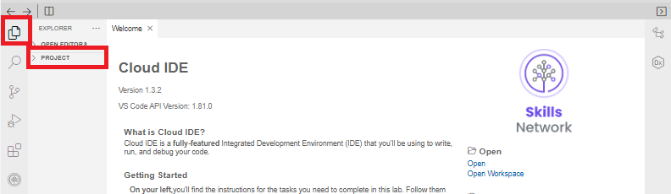
2. Click on **Project.** Select **New File** to create you first C program.  
   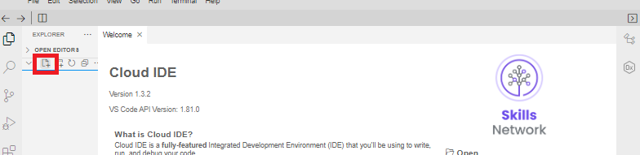
3. Enter the file name as helloworld.c and press OK.

C programs have the extension **.c**.

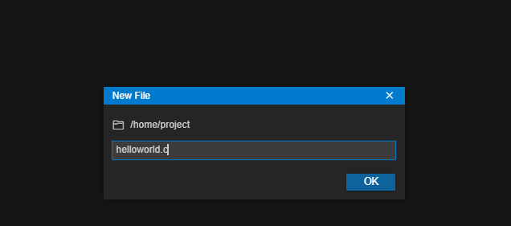

1. This will open the file.

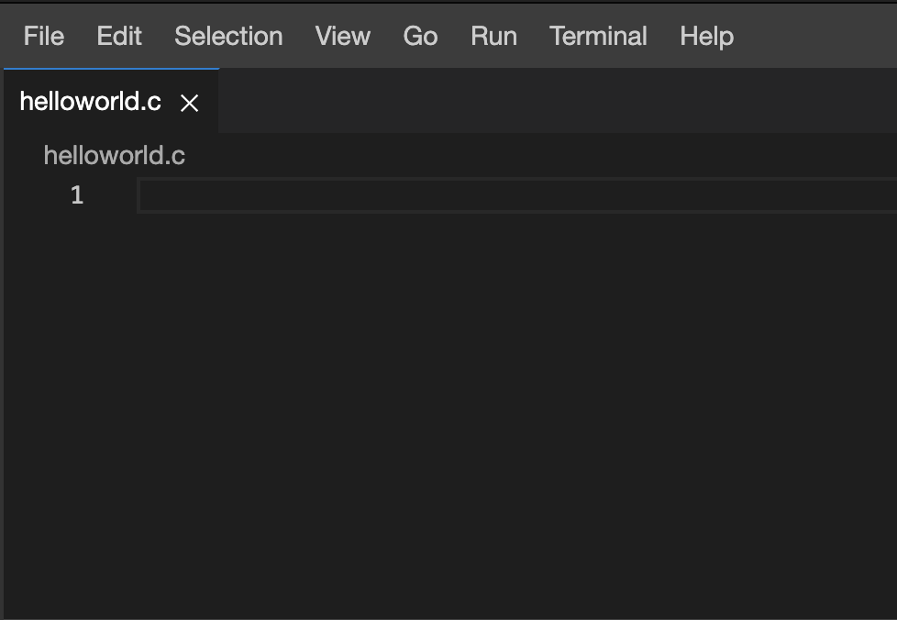

1. Copy and paste the following code into the file. In the printf statement, makes sure there is the newline character \n after the message on the output window, when you run the code.
2. #include <stdio.h>
3. int main(void) {
4. printf("Hello World!\n");
5. return 0;
6. }

This is how the file would appear on your window, after you paste the code and save it.

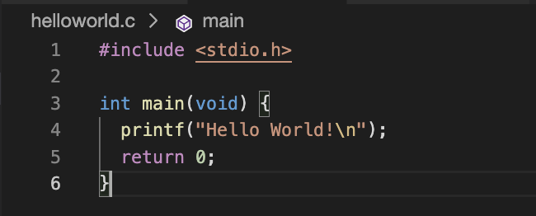

1. Click on **File** menu and choose **Save** to save the changes.
2. In the terminal now compile the code by typing or copying and pasting the following command followed by **Enter** or **return** key. **gcc** is a C program compiler. **-o** specifies the name of the output file.
3. gcc -o hello helloworld.c

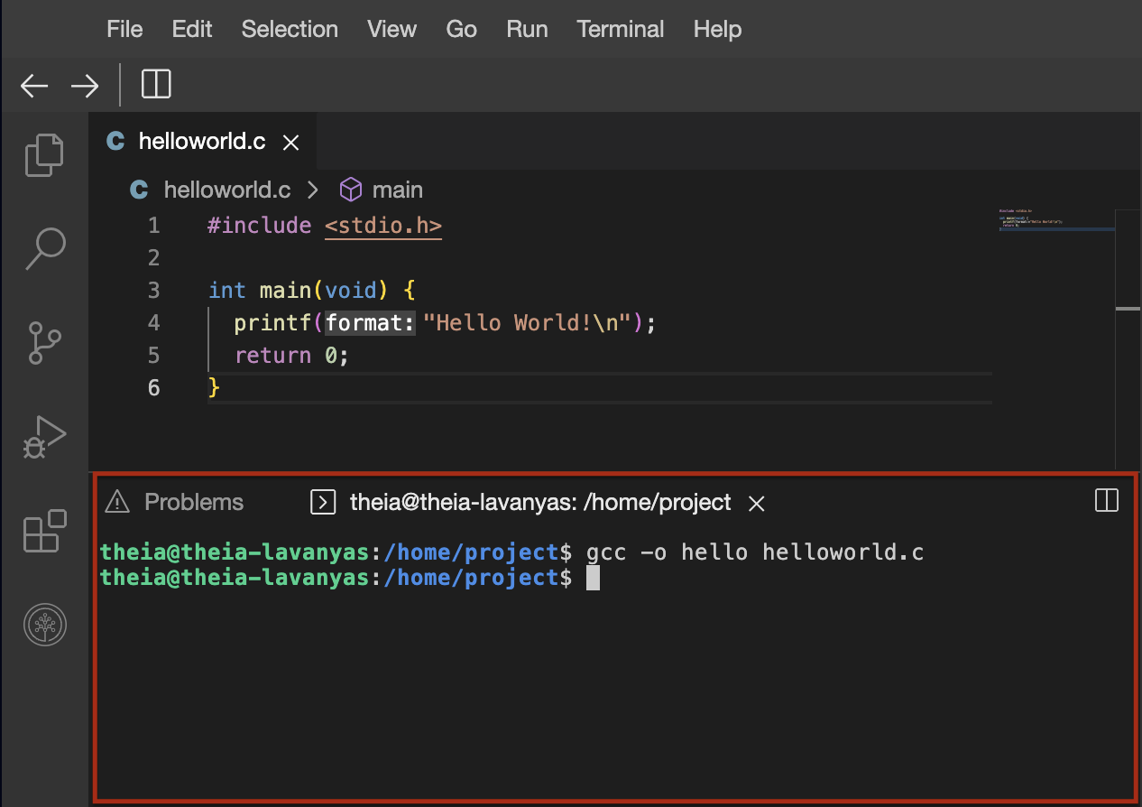

1. To run the compiled file, type or copy paste the following command in the terminal and press enter. You will see the output of your first c program.
2. ./hello



**Exercise 2: Display Hello World using Java**

Java is an Object-Oriented Programming language and is based on C++. It is one of the most used languages for building secure and robust applications.

1. Click on the **File** menu and click on **New File** to create you first Java program.
2. Enter the file name as helloworld.java and press OK.

Java programs have the extension **.java**.



1. This will open the file.
2. Copy and paste the following code into the file.
3. public class helloworld {
4. public static void main(String s[]){
5. System.out.println("Hello World!");
6. }
7. }

This is how the file would appear on your window, after you paste the code and save it.

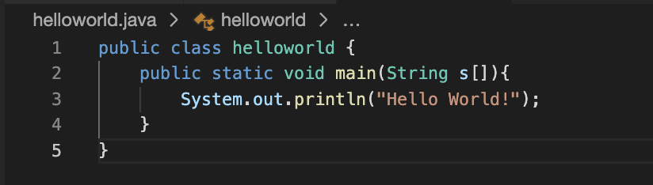

1. Click on **File** menu and choose **Save** to save the changes.
2. In the terminal now compile the code by typing or copying and pasting the following command followed by **Enter** or **return** key. **javac** is a Java program compiler. By default the compilation output is stored in a file will the same name and **.class** extension.
3. javac helloworld.java
4. To run the compiled file, type or copy paste the following command and press enter. You will see the output of your first Java program.
5. java helloworld



**Exercise 3: Display Hello World using Python**

Python is a scripting language. It is run as is and you cannot compile and create executable file from them.

1. Click on the **File** menu and click on **New File** to create you first Python program.
2. Enter the file name as helloworld.py and press OK.

Python scripts have the extension **.py**.



1. This will open the file.
2. Copy and paste the following code into the file.
3. print("Hello World!")

This is how the file would appear on your window, after you paste the code and save it.

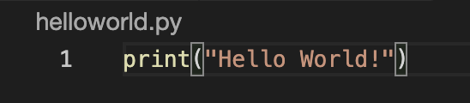

Yes! That’s right. It is just a one line code in Python.

1. Click on **File** menu and choose **Save** to save the changes.
2. There is no compilation for Python code. To run the compiled file, type or copy paste the following command in the terminal and press enter. You will see the output of your first Python program.
3. python3 helloworld.py

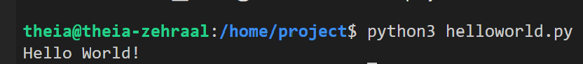

**Exercise 4: Display Hello World using Node JS**

JavaScript is a scripting language. Javascript was initially used only for executing code in the web pages. Node JS is scripting language for writing code that can be run. It is run as is and you cannot compile and create executable file from them just like Python.

1. Click on the **File** menu and click on **New File** to create you first Node js program.
2. Enter the file name as helloworld.js and press OK.

Node.js scripts have the extension **.js**.



1. This will open the file.
2. Copy and paste the following code into the file.
3. console.log("Hello World!");

This is how the file would appear on your window, after you paste the code and save it.

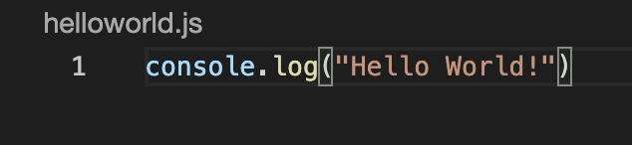

Yes! That’s right. It is just a one line code in Node.js too. This is why most people start learning coding with scripting languages.

1. Click on **File** menu and choose **Save** to save the changes.
2. There is no compilation for Node.js code. To run the compiled file, type or copy paste the following command in the terminal and press enter. You will see the output of your first Node.js program.
3. node helloworld.js



**Exercise 5: Display Hello World using Go**

Go is a programming language. It is created by Google and is an Object-Oriented Programming language just like Java. It is now increasing in popularity.

1. Click on the **File** menu and click on **New File** to create you first Go program.
2. Enter the file name as helloworld.go and press OK.

Go programs have the extension **.go**.



1. This will open the file.
2. Copy and paste the following code into the file.
3. package main
4. import "fmt"
5. func main() {
6. fmt.Println("Hello World!")
7. }

This is how the file would appear on your window, after you paste the code and save it.

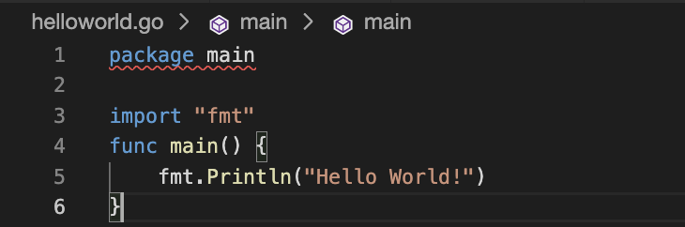

1. Click on **File** menu and choose **Save** to save the changes.
2. Go code has to be compiled and executed like C and Java. But you can do that with one command. To comnpile and run the compiled file, type or copy paste the following command in the terminal and press enter. You will see the output of your first Go program.
3. go run helloworld.go



The exercises below are optional. It is only for you to do if you want to get a taste of more languages. You also have a bonus exercise at the end.

**Exercise 6: Display Hello World using Ruby**

Ruby is also a scripting language. It is predominantly used in data science and data analytics. It is run as is and you cannot compile and create executable file from them just like Python.

1. Click on the **File** menu and click on **New File** to create you first Ruby program.
2. Enter the file name as helloworld.rb and press OK.

Ruby scripts have the extension **.rb**.

1. This will open the file.
2. Copy and paste the following code into the file.
3. puts "Hello World!";

This is how the file would appear on your window, after you paste the code and save it.

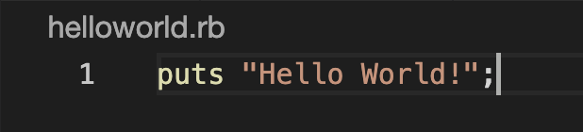

Yes! That’s right. It is just a one line code in Ruby as in other scripting languages too. This is why most people start learning coding with scripting languages.

1. Click on **File** menu and choose **Save** to save the changes.
2. There is no compilation for Ruby code. To run the compiled file, type or copy paste the following command in the terminal and press enter. You will see the output of your first Ruby program.
3. ruby helloworld.rb



**Exercise 7: Display Hello World using PHP**

PHP is also a scripting language. It stands for Hypertext Preprocessor. It is used for server side scripting. It is run by embedding it within special tags which recognize it as PHP code.

1. Click on the **File** menu and click on **New File** to create you first PHP program.
2. Enter the file name as helloworld.php and press OK.

PHP files have the extension **.php**.

1. This will open the file.
2. Copy and paste the following code into the file.
3. <?php
4. Print "Hello, World!\n";
5. ?>

This is how the file would appear on your window, after you paste the code and save it.

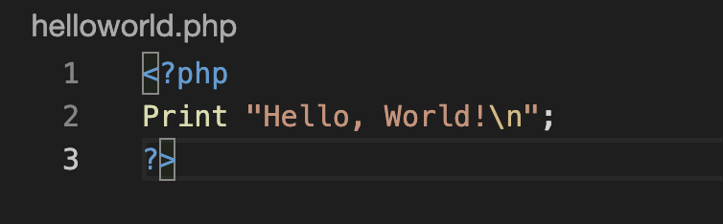

Yes! That’s right. It is just a one line code in PHP as in other scripting languages too but it has to be embedded within the php tags for the interpreter to understand it is php script.

1. Click on **File** menu and choose **Save** to save the changes.
2. There is no compilation for PHP code. To run the compiled file, type or copy paste the following command in the terminal and press enter. You will see the output of your first PHP program.
3. php helloworld.php



**Exercise 8: Display Hello World using C++**

C++ is one of the first Object Oriented Programming languages that has been widely used for a few decades now. Java, Go and C# are all based on C++. You cannot run it as is. You need to compile it to obtain an executable form.

1. Click on the **File** menu and click on **New File** to create you first C++ program.
2. Enter the file name as helloworld.cpp and press OK.

C++ files have the extension **.cpp**.

1. This will open the file.
2. Copy and paste the following code into the file.
3. #include <iostream>
4. int main() {
5. std::cout << "Hello World!\n";
6. return 0;
7. }

This is how the file would appear on your window, after you paste the code and save it.

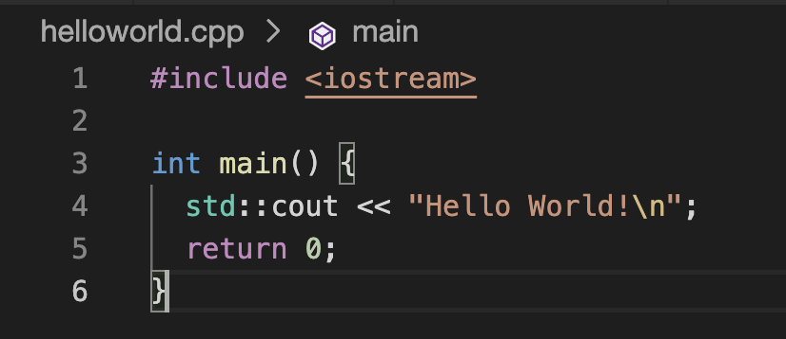

1. Click on **File** menu and choose **Save** to save the changes.
2. In the terminal now compile the code by typing or copying and pasting the following command followed by **Enter** or **return** key. **g++** is a C++ program compiler. The executable output is stored in the filename specified.
3. g++ -o helloworld_cpp helloworld.cpp
4. To run the compiled file, type or copy paste the following command in the terminal and press enter. You will see the output of your first C++ program.
5. ./helloworld_cpp



**Exercise 9: Display Hello World using Perl**

Perl is also a scripting language. It is one of the older scripting languages and has been around for nearly 35 years. It is run as is and you cannot compile and create executable file from them just like Python.

1. Click on the **File** menu and click on **New File** to create you first Perl program.
2. Enter the file name as helloworld.pl and press OK.

Perl scripts have the extension **.pl**.

1. This will open the file.
2. Copy and paste the following code into the file.
3. print("Hello World\n");

This is how the file would appear on your window, after you paste the code and save it.

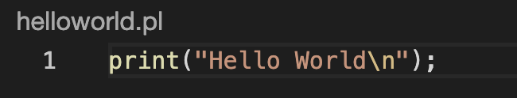

Yes! That’s right. It is just a one line code in Perl too, as in other scripting languages too.

1. Click on **File** menu and choose **Save** to save the changes.
2. There is no compilation for Perl code. To run the file, type or copy paste the following command and press enter. You will see the output of your first Perl program.
3. perl helloworld.pl



**Exercise 10: Display Hello World shell script**

Shell scripts are unique to UNIX operating system. It is one of the older scripting languages and is used for running system procedures predominantly. It is run as is like other scripting languages.

1. Click on the **File** menu and click on **New File** to create you first shell script.
2. Enter the file name as helloworld.sh and press OK.

Shell scripts have the extension **.sh**.

1. This will open the file.
2. Copy and paste the following code into the file.
3. echo "Hello World!"

This is how the file would appear on your window, after you paste the code and save it.  
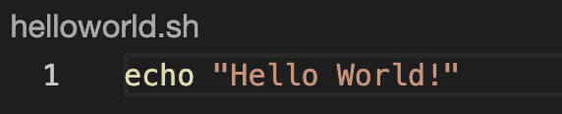

1. Click on **File** menu and choose **Save** to save the changes.
2. There is no compilation for Perl code. To run the file, type or copy paste the following command and press enter. You will see the output of your first shell script.
3. sh helloworld.sh



**Exercise: Display Hello World with HTML on your browser**

We worked on many programming and scripting languages. There is another kind called the Mark-up language. Many will be familiar with the most common markup language called the HTML. It stands for Hypertext Markup Language and is used for web-pages.

1. Click on the **File** menu and click on **New File** to create you first HTML code.
2. Enter the file name as helloworld.html and press OK.

HTML code, usually referred to as HTML pages have the extension **.html**.

1. This will open the file.
2. Copy and paste the following code into the file.
3. <html>
4. Hello World!
5. </html>

This is how the file would appear on your window, after you paste the code and save it.

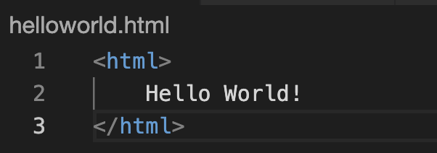

1. Click on **File** menu and choose **Save** to save the changes.
2. There is no compilation for HTML code. It is interpreted by the browser while rending. Right click on the filename and click **Download** to download it in your local machine.

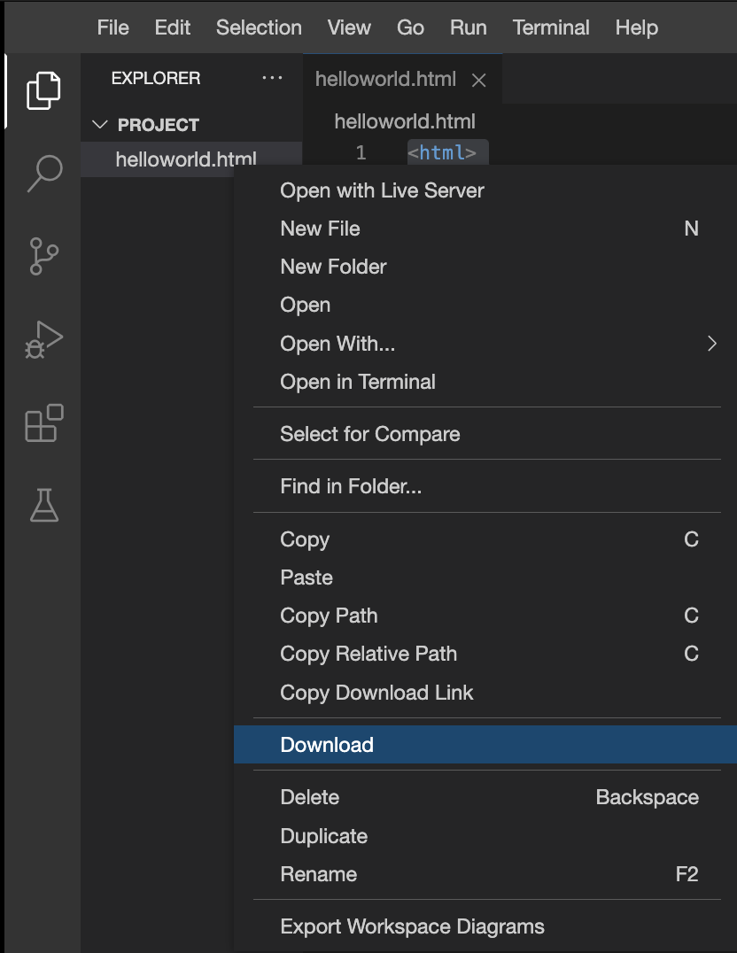

1. Open on the downloaded file and it automatically opens in your default browser as below.

